|  |  |  |
| --- | --- | --- |
|  |  | Rutland south Beat  **Crimes of Note: November 2023** |
| PC Pete Icke 2113 **As part of our ongoing drive to reduce demand did you know that you can report a "NON-EMERGENCY" crime and find lots of useful information on our new improved web site.** [**www.leics.police.uk**](http://www.leics.police.uk)  Please look out for any vulnerable people in our community and if at all concerned, please raise this concern to the relevant agencies. You can also raise these concerns with myself.  **Parish Meeting:** If any parishes would like the beat team to join them, please let me know (subject to being on duty). Contact WEBSITE:[www.leics.police.uk](http://www.leics.police.uk) |  | Burglary 2nd - Lyddington – Car key break, property entered for keys to high powered car taken from road side – later recovered. Criminal damage - theft 1st – Morcott – theft from store Assault - vehicle crime 1st – Ayston – van broken into and large amount of power tools stolen.  10th – Empingham – Theft from tractor  16th – Empingham – Theft of Land Rover Discovery – later recovered.  22nd – Braunston - Theft of Land Rover Discovery – later recovered Other 5th - Morcott – Poaching offences – 2 persons helping with enquires.  12th – Morcott – drugs possession  24th – Morcott – Bilking – theft of fuel – non-payment    **In Summary** |

This month, there has been a rise in Land Rover Discovery thefts, mirroring a trend in other regions. Perpetrators often gain entry by cloning key codes. To prevent this, consider using a storage pouch like ‘faraday bags’ or ‘signal blockers’ for your keys. These are readily available online for approximately £5, so well worth investing in. Additionally, store any spare keys in a similar manner for added security.

We have had one residential break in the month of November resulting in a high-powered car being stolen, with the usual purpose to be used in crime. As we are now into the darker nights, please remain vigilant. Ensure your doors and windows are always locked and leave lights on if you go out.

We have had no commercial / rural breaks this month on the south beat - rural locations including building sites and Farms are often targeted as their plant equipment are highly desired commodities due to demand exceeding worldwide supply. We continue to run operation Vitality for rural crime with extra officers out patrolling.

If you see witness or suspect anything similar happening, please call the police. Your call may be all that’s required to catch them in the act!



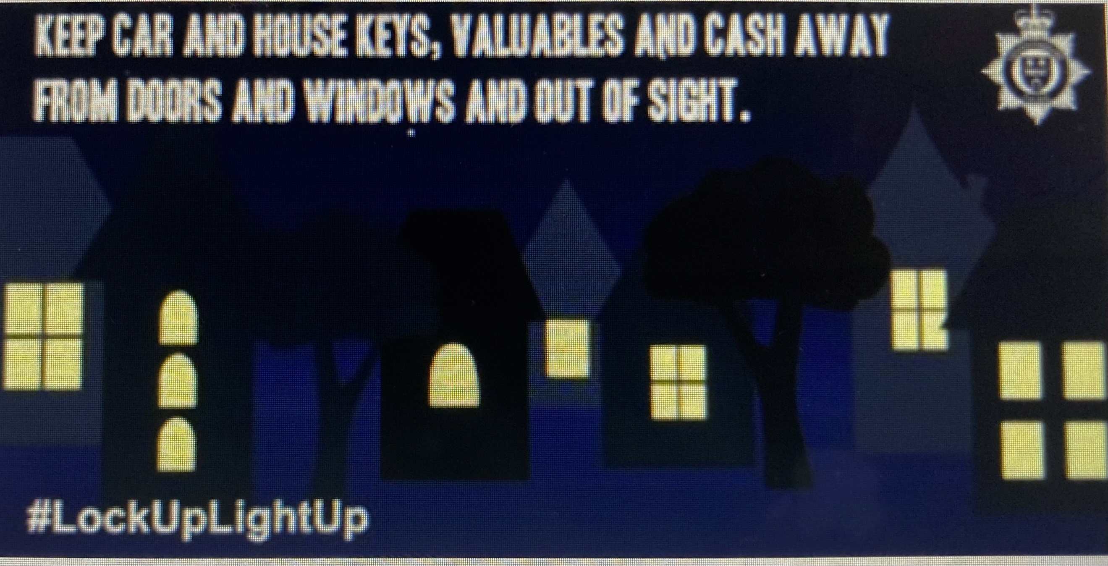

Burglars will use a variety of ways to avoid being noticed.

They don’t want to be seen or heard by a neighbour or passer-by because they will feel exposed and identifiable.

Distraction burglars will pretend to be someone they are not, so it’s important you are aware of the common methods they will use to get you to let them into your property.

Here’s some useful advice, firstly on helping to keep burglars out by giving them no hiding place and, secondly, on how to prevent a distraction burglary.

**Keep it visible**

You’d think that it would be best to make a property less visible from the street, and to keep it hidden from prying eyes behind overgrown bushes, trees, high fences or walls. In reality, all that this serves to do is make it easier for a burglar to get close to a home unnoticed and provide somewhere to hide while carrying out a burglary or theft from the property.





1. Lower fences at the front around one-metre high are preferable to high fences as they allow for a clear view over the top and don’t provide cover for anyone wishing to hide.
2. At the rear and sides, taller fencing is recommended to prevent easy access.
3. Trellis, thorny plants, or a suitable anti-climb topping such as plastic spikes make it difficult for anyone climbing over a fence or gate.
4. Planting prickly or barbed shrubbery along boundaries and fence lines acts as an effective natural barrier.
5. Gravel driveways and paths will make sure you hear anyone approach.

For more information on creating a boundary, visit our [advice on criminal damage](https://www.leics.police.uk/cp/crime-prevention/protect-home-crime/property-vandalism/)

### Distraction burglary

Distraction burglars pretend to be someone they are not in order to gain entry to your home.

#### Common methods used by distraction burglars

* pretending to be from a care agency, the council or a utility company investigating a gas or water leak
* seeking help to leave a note for a neighbour or even asking for a drink of water if they claim to be thirsty or unwell
* claiming to be in a hurry or emergency and needing to get into your home quickly
* working in teams, with one person distracting you while the other searches your home

#### How to prevent it

There are a number of things you can do to prevent distraction burglary. Always remember "if in doubt, keep them out":

* use your door viewer to see who’s there
* if you open the door put the chain on first
* always ask for ID and check it with the company before letting somebody into your home
* use the phone number advertised in the phone book or online, as the number on their identity card could be fake. For a utility company, call the customer service department. Close the door while you do this
* remember that genuine callers won’t mind checks. If you feel at all unsure, schedule a time for the caller to come back when a friend or relative is there
* for pre-planned appointments with utility companies, a password scheme can be set up

If you feel threatened or in danger by the presence of the caller, call [999](tel:999).

**NEIGHBOURHOOD LINK**

We continue to encourage local residents to have their say through Neighborhood Link surveys and keep all residents that have signed up to this aware of issues happening in Rutland.

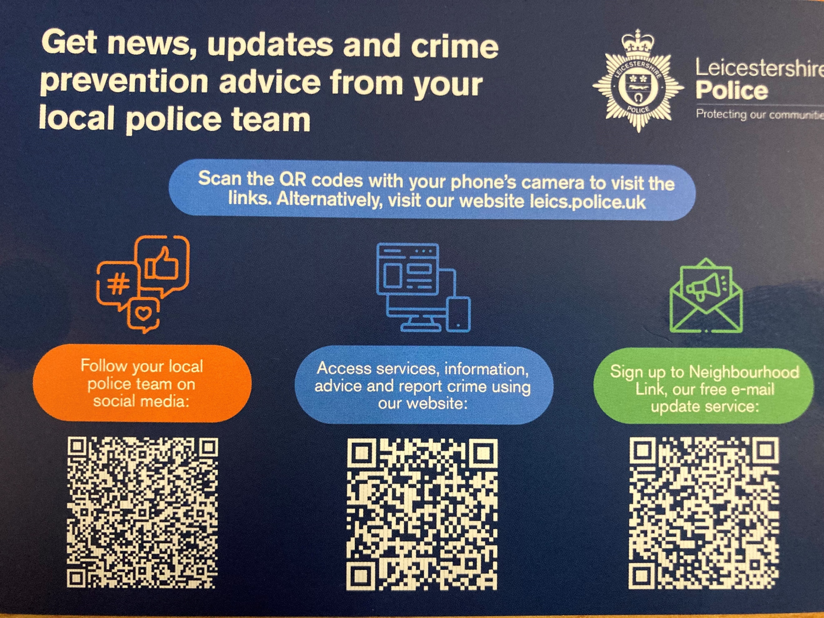

## Beat PRIORITIES

Nuisance Motorbikes

Road Safety Issues

Rural Crime/farming equipment

**Operation ENFORCE**– has been created to reduce speeding and road safety issues including nuisance motorbikes especially at weekends.

We continue to conduct speed monitoring and enforcement utilising the SL700 laser speed meter on the beat

# **Volunteers for Independent Advisory Groups sought**

Leicestershire Police are seeking volunteers to become part of the Independent Advisory Groups (IAGs) to help advise and shape policing in Leicester, Leicestershire and Rutland.

The groups have been part of the policing landscape for many years but new volunteers from diverse groups are needed to ensure that the right voices are heard.

The purpose of IAGs is to facilitate genuine partnerships with local communities across Leicester, Leicestershire and Rutland to encourage more active involvement of and with people from the full range of diverse groups.

Officers are seeking a network of individuals independent of the police drawn from across the county who offer a diversity of background, perceptions, ideas, knowledge, and skills which form one part of the jigsaw of wider community consultation and engagement.

Chief Constable Rob Nixon said: “IAG’s are a vital part of how we listen to the community and we are seeking a wide range of people to help us hear what the public experience is and therefore really help shape policing in our area. In my long career of over 30 years I have worked with a number of wonderful people who have made significant contributions to policing ensuring that the local voice is heard and I would encourage anyone who is interested to get in touch and join our IAGs.”

Leicestershire Police are seeking people who can help build insight into the needs, wants and concerns of communities in decision making processes. The role is not to provide specialist advice but more as a ‘critical friend’ to the police, challenging conventional thinking and providing an independent perspective on issues, working as a genuine partner with the police to inform and promote improvements.

Volunteers are sought to provide advice on the public’s perception of policing and to contribute to thinking around the development of policies and practices. By being part of the IAG you can contribute to the thinking behind policies and policing practices and help build trust and confidence in the police.

Inspector Yakub Ismail said: “We are reaching out into our communities to find people who care about how policing is delivered and want to ensure their voices are heard. The IAG are a really important part of shaping the policing landscape and we would really like to hear from anyone who is interested in taking part.”

Leicestershire Police will have 11 local IAGs who meet quarterly covering each of the Neighbourhood Policing Areas:

Charnwood

West Leicester

Northwest Leicestershire

Harborough and Wigston

Central Leicester

Hinckley

Melton

South Leicester

East Leicester

Blaby

Rutland

Applications can be found here [Independent Advisory Groups | Leicestershire Police (leics.police. https://www.leics.police.uk/police-forces/leicestershire-police/areas/leicestershire-force-content/about-us/about-us/independent-advisory-groups/uk)](https://eur01.safelinks.protection.outlook.com/?url=https%3A%2F%2Fwww.leics.police.uk%2Fpolice-forces%2Fleicestershire-police%2Fareas%2Fleicestershire-force-content%2Fabout-us%2Fabout-us%2Findependent-advisory-groups%2F&data=05%7C01%7CCorporate.Communications%40leics.police.uk%7Cfc5723d75d354adc250208dbeb64d5b1%7C6b0ff425e5e24239bd8b91ba02b7940a%7C0%7C0%7C638362590524171632%7CUnknown%7CTWFpbGZsb3d8eyJWIjoiMC4wLjAwMDAiLCJQIjoiV2luMzIiLCJBTiI6Ik1haWwiLCJXVCI6Mn0%3D%7C3000%7C%7C%7C&sdata=6Tf%2FEe%2F2JEbZlL0V5%2F4swDDKv0SWgBXUtfZaw7piAlI%3D&reserved=0) and you can apply anytime as the process will remain open to encourage new members. If you have any further enquiries please contact us via: [IAG@leics.police.uk](mailto:IAG@leics.police.uk)

**Our up and coming beat surgeries**.

We will be popping into the tea party on Tuesday 28th November 2023 at Braunston Village Hall 1 Wood Lane, Braunston between 2.30pm – 3.30pm

